|  |  |  |  |
| --- | --- | --- | --- |
| 1 | | 54,984 | |
| **NUMERO DE FRONTERAS** | | **ENERGIA AGREGADA** | |
|  | | | |
| 34,566,816 | 36 | | 1,475,577 |
| INGRESO 2019 | DÍAS CERTIFICADOS 2019 | | ENERGIA RESPALDADA 2019 |
|  | | | |
| 429,306,924 | 214 | | 15,762,233 |
| INGRESO 2020 | DÍAS CERTIFICADOS 2020 | | ENERGIA RESPALDADA 2020 |
|  | | | |
| 170,445,325 | 136 | | 7,476,509 |
| INGRESO 2021 | DÍAS CERTIFICADOS 2021 | | ENERGIA RESPALDADA 2021 |

**HISTORICO REINTEGRO DDV**

|  |  |  |  |
| --- | --- | --- | --- |
|  | **2019** | **2020** | **2021** |
| **ENE** | - | 66.33 | 22.34 |
| **FEB** | 15.89 | 81.87 | 20.89 |
| **MAR** | 1.1 | 97.19 | 17.24 |
| **ABR** | 17.58 | - | 1.37 |
| **MAY** | - | 4.66 | 33.06 |
| **JUN** | - | 12.63 | 28.45 |
| **JUL** | - | 50.72 | 24.23 |
| **AGO** | - | 36.32 | - |
| **SEP** | - | 0.72 | 2.57 |
| **OCT** | - | 15.19 | 20.29 |
| **NOV** | - | 32.45 | - |
| **DIC** | - | 31.22 | - |

**Los valores de la tabla están en millones de COP**

**REINTEGRO MECANISMO DDV OCTUBRE 2021**

|  |  |  |  |  |  |
| --- | --- | --- | --- | --- | --- |
| FECHA | TIPO DIA | CANTIDADES RESPALDO | PRECIO PONDERADO USD | TRM | PNETO |
| 2021-10-06 | Miércoles | 54,982 | 5.98 | 3,784.44 | 1,127,331 |
| 2021-10-07 | Jueves | 54,982 | 5.98 | 3,784.44 | 1,127,331 |
| 2021-10-08 | Viernes | 54,982 | 5.98 | 3,784.44 | 1,127,331 |
| 2021-10-09 | Sábado | 54,982 | 5.98 | 3,784.44 | 1,127,331 |
| 2021-10-10 | Domingo - Festivo | 54,982 | 5.98 | 3,784.44 | 1,127,331 |
| 2021-10-11 | Lunes | 54,982 | 5.98 | 3,784.44 | 1,127,331 |
| 2021-10-18 | Domingo - Festivo | 54,980 | 5.98 | 3,784.44 | 1,127,290 |
| 2021-10-19 | Martes | 54,980 | 5.98 | 3,784.44 | 1,127,290 |
| 2021-10-20 | Miércoles | 54,980 | 5.98 | 3,784.44 | 1,127,290 |
| 2021-10-21 | Jueves | 54,980 | 5.98 | 3,784.44 | 1,127,290 |
| 2021-10-22 | Viernes | 54,980 | 5.98 | 3,784.44 | 1,127,290 |
| 2021-10-23 | Sábado | 54,982 | 5.98 | 3,784.44 | 1,127,331 |
| 2021-10-24 | Domingo - Festivo | 54,980 | 5.98 | 3,784.44 | 1,127,290 |
| 2021-10-25 | Lunes | 54,980 | 5.98 | 3,784.44 | 1,127,290 |
| 2021-10-26 | Martes | 54,982 | 5.98 | 3,784.44 | 1,127,331 |
| 2021-10-27 | Miércoles | 54,982 | 5.98 | 3,784.44 | 1,127,331 |
| 2021-10-28 | Jueves | 54,980 | 5.98 | 3,784.44 | 1,127,290 |
| 2021-10-29 | Viernes | 54,980 | 5.98 | 3,784.44 | 1,127,290 |

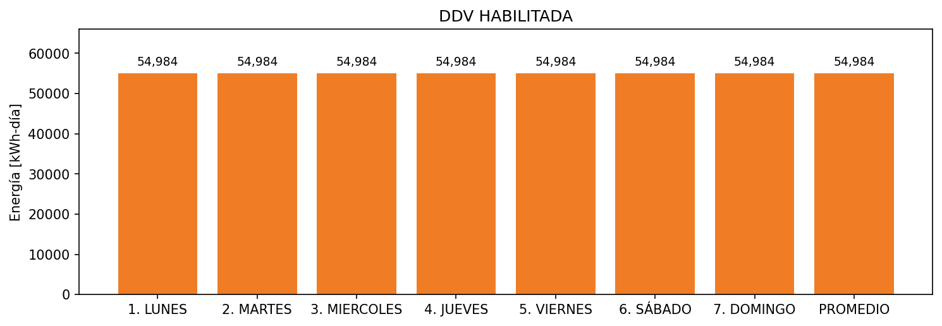

|  |  |  |  |  |  |  |  |  |  |
| --- | --- | --- | --- | --- | --- | --- | --- | --- | --- |
| **FRONTERA** | **COD SIC** | **FRT DDV** | **TIPO DDV** | **PROMEDIO** | **PRÓXIMA ACTUALIZACIÓN** | **MARGEN DE ERROR** | **ÚLTIMA PRUEBA DDV** | **DÍAS PARTICIPACIÓN** | **FECHA REFERENCIA PRÓXIMA PRUEBA DDV** |
| COLOMBINA DEL CAUCA S.A. | Frt02994 | Frt35942 | GPE | 54,984 | 2023-04-15 | NO APLICA | 2021-09-16 | 20.0 | 2022-02-20 |